PROJECT REPORT FORMAT
- The project report shall be written in Times New Roman with a text font size of 12 and 1.5 line spacing.
- Paper size = A4.
- Margins : Left 1 inch, Right, Top & Bottom = 1.00 inch.
- Chapter No. : font size = 12 , Lower Case, Bold.
- Chapter Name : font size = 16 , Upper Case, Bold.
- First-order headings : font size = 12 , Upper Case, Bold, flush left, with one blank line before, and one blank line after.
- Second-order Heading : font size = 12 , Lower Case, Non Bold, flush left, with one blank line before, and one after.
- Third-order Heading : font size = 12 , Lower Case, Non Bold, Underline, flush left, preceded by one blank line, followed by a period and your text on the same line.
- Graphics, Tables & Figures must be given with captions.
- All printed material, including text, illustrations, and charts, must be kept within a print area.
- No borders on any page.
- Circuit diagrams shall be drawn using any computer tools.
- All equations / Expressions must be typed in Mathworks or similar tool.
- Write PRMITR, Badnera on bottom left corner of every page.
- List and number all bibliographical references in 9-point Times, single-spaced. When referenced in the text, enclose the citation number in square brackets, for example [1]. Where appropriate, include the name(s) of editors of referenced books / Papres. e.g.
[1] A.B. Smith, C.D. Jones, and E.F. Roberts, “Article Title”, Journal, Publisher, Location, Date, pp. 1-10.
[2] Jones, C.D., A.B. Smith, and E.F. Roberts, Book Title, Publisher, Location, Date.

CONTENTS
CHAPTER 1: INTRODCUTION
CHAPTER 2: LITERATURE SURVEY
2.1 Overview and all theory related to project
CHAPTER 3: METHODOLOGY
3.1 System Block Diagram
3.2 Description
3.3 Flow charts
CHAPTER 4: IMPLEMENTATION
4.1 Simulation
4.2 working of project
4.3 Actual pictures
4.4 Circuit diagram, PCB layout diagram etc.
CHAPTER 5: COMPONENT DESCRIPTION
CHAPTER 6: APPLICATION
CHAPTER 7: ADVANTAGES AND DISADVANTAGE
CHAPTER 8: CONCLUSION AND FUTURE SCOPE
REFERENCE
APPENDIX: PROGRAM

Guidelines for students
- Student are instructed to follow the given format
- Edit only Highlighted part in first pages, Certificate acknowledgement etc.
- For example: Title of Project & Name of students shown in below picture
- 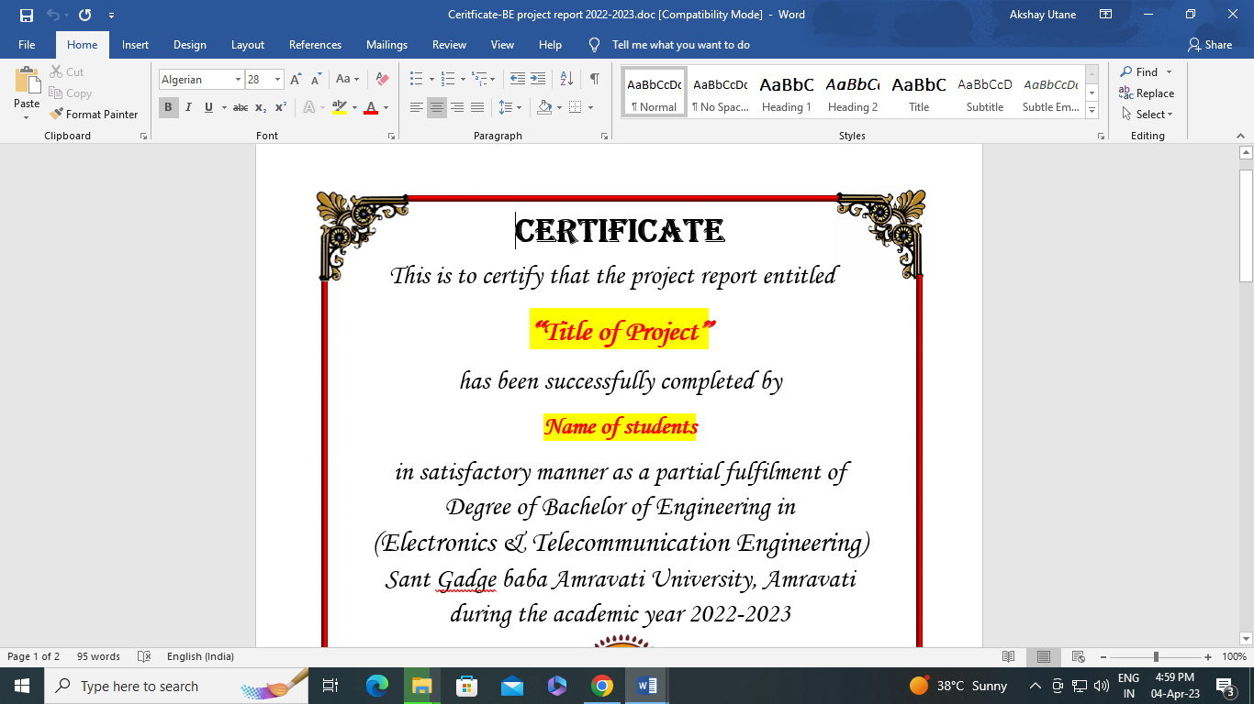

Name of Students must be replace by group of students
For Ex. ABC
XYZ
PQR
